BI Link:

Below is the BI link and picture of the assignment.

<https://app.powerbi.com/groups/e09ef0a8-4c49-4167-8949-706be8737c63/reports/d0d053c2-5d1a-4bbc-81a1-9aca2ec18bb5/4142c6e7a532e3acb521?experience=power-bi>

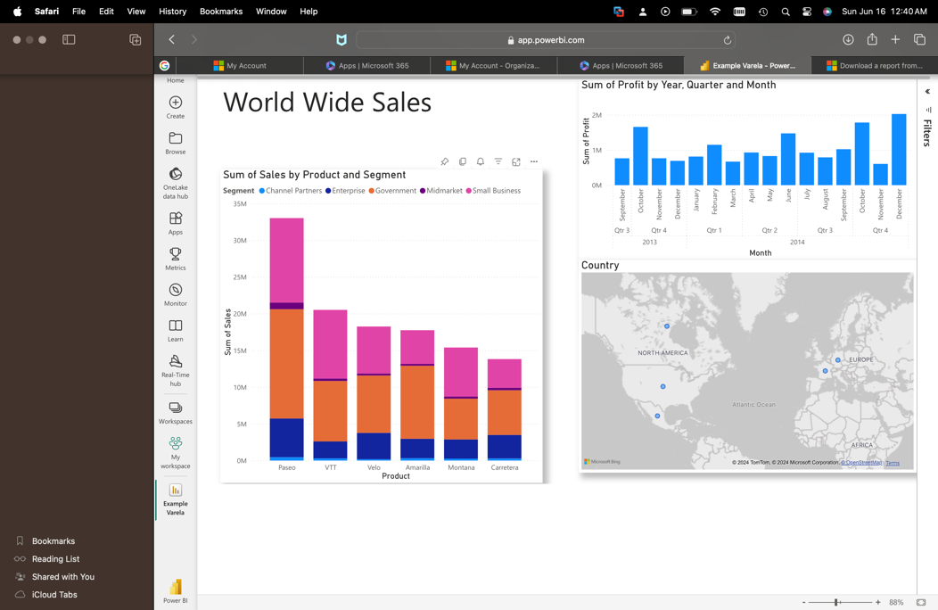

Azure Link:

Attached is the Azure Link and Picture of the assignment.

<https://ml.azure.com/fileexplorerAzNB?activeFilePath=Users/ajvarela1/quick-start.ipynb&tid=9cf5074d-3cb5-44a3-a59c-d4e900450029&wsid=/subscriptions/0dd14236-1530-4844-b645-efe9bcad9634/resourcegroups/ai-powered-bi/providers/Microsoft.MachineLearningServices/workspaces/auto-ml>

